Word Corpus Processing and Vectorization
Kent Roller

Introduction
Text data has long been a difficult task to tackle. Due to the way language has developed, dictionaries of words tend to be long and cumbersome. What’s more, in a given document, a large array of words can be used, which means even analyzing a small number of documents can prove to be a cumbersome task. That is until the technology was finally able to catch up to the techniques that had been developed prior. Looking through large amounts of text data and trying to piece together meaningful information is nothing new. Many of the techniques employed to this day have their roots in research dating back to the 1950s, and many of the statistical methods employed in that research date back even further. However, with the increase in storage and compute capacity, as well as rapidly diminishing storage and compute cost, many of these techniques are now able to be used to great effect. The text data in question can come in many forms, such as word documents, or even a pre-sorted matrix of words from a previous collection of documents. One such type of data source is known as corpus, often a collection of documents or even collections of books, stored in a format that differs from .txt or .csv files. This corpus is similar in structure to that of a python dictionary, where a label is applied to a string that stores the text data. The end result of using this data is the same, but the loading and handling of corpus does differ slightly from other formats.

Method
The dataset being used comprises of text data or SMS data collected from volunteers. The dataset is stored in the form of a corpus, supplied from Kaggle[1]. The data is already labeled with ‘ham’ being non spam messages and ‘spam’ being malicious messages. The primary objective is to import the corpus and then perform vectorization on the corpus utilizing both the Tfidf vectorization method and the Count Vectorizer vectorization method. Since the corpus in question contains text data, the stop words used on the data will be limited to punctuation alone. This may seem counterintuitive, but the reasoning behind this is due to how many text messages are formed, and the difference in count frequency between the two groups. The punctuation was removed using a REGEX statement, if this statement is not complete then some non-alphanumeric characters may have passed through the removal process. For comparison of columns resulting from the vectorization process, the column count was inspected between tfidf vectorization output both with and without the punctuation intact. Interestingly, the vectorization output including the punctuation resulted in a column count of 8714, while the removal of the punctuation in the corpus resulted in a vectorization output with a column count of 9457. The thought behind why this may have occurred when one might expect the number of columns to decrease is as follows: In vectorization words are mapped to a vector to allow for analyzing in a higher dimensional space. Each observation can be considered a potential vector in the space, meaning the number of dimensions in the space is equal to the total length of the overall dictionary being used across all text being analyzed. Since each of the unique words in the space can be considered an observation, then so too can non alpha numeric characters. The number of punctuation characters is limited, where as the potential for possible words in a given language is large. As such, when the punctuation is left intact, the vectorization process may count certain words that lack a white space following punctuation as \Hello or \Hey as their own observation, so that any word beginning with “\” may be considered as an observation marked as punctuation. In turn, there may be several observations omitted from the original space as they are counted as punctuation instead of as individual words. It should be noted here, that this is speculation on the authors part, and is by no means meant to be an exhaustive or factual discussion about how vectorizer logic is applied to documents.
After the column count comparison was made, both the Tfidf vectorizer and the CountVec vectorizer were used on the data without the punctuation left in place. It is this data that will be analyzed to check for differences in word ranking and frequency counts using each method. This comparison is not meant to determine which vectorization method is superior, but rather, the comparison is meant to simply look at what words each of the vectorization processes prioritize and place the most significance behind. Some consideration should be taken here when selecting a method for machine learning purposes, as based on which words the vectorization process favors may alter the outcome of the machine learning process. This may not be a large contributing factor to the outcome but since there is variation between the methods it is something that should be given consideration.

Results
The results of the analysis between the output of the two methods is examined here. For both the CountVectorizer and the Tfidf vectorization methods, tables have been made to compare the output of the top 10 words for both label groups, spam and ham. Following this, wordclouds were generated using the vectorized text. The vectorization was applied to the data while in corpus form, however, after vectorization, the data was put into an array where it was then put into a dataframe. The reasoning behind this is that while the machine learning process may favor the data to not be in a dataframe, count analysis and ranking is made easier (from the authors perspective) when working with dataframes. Again, the vectorization was applied to the corpus directly but the results are ported to an alternate format.
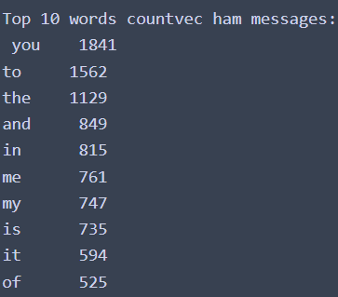
Fig 1.1 Top 10 Non-Spam Words for CountVec Method
In figure 1.1 the resulting top 10 words for the CountVectorizer applied to the non spam words can be seen. There are many words that would typically be regarded as stop words in most text analysis, however here these words give us an insight into how people in this region speak on a regular basis and in an informal manner. Breaking down this information and comparing it to how spam messages are constructed can give us a clear cut method of detecting when a message may be spam and when it may be a real person. Expected high frequency words like “you” or “the” do not necessarily provide much insight. But, words being used in the 1st person possessive such as my, or words that dictate 1st person reference such as me, are fairly high on the list. Likewise, the word “of” ranks in the top 10 as well for non spam messages. The word “of” is a preposition, and in many cases can be used to indicate possession or origin. It is also worth noting what is not observed, which the word “your” in this list for non spam messages.
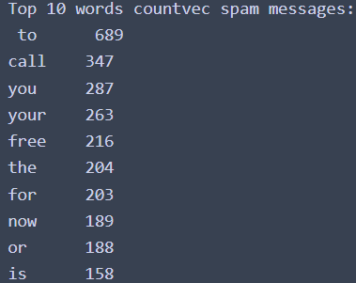
Fig 1.2 Top 10 Spam Words for CountVec Method
In figure 1.2 the top 10 words for the CountVectorizer applied to the spam label can be observed. Here, many similarities between Fig 1.2 and Fig1.1 can be seen, such as the inclusion of words like “you”, “to”, and “the” which occur with a relatively high frequency in both lists. But there are also some stark contrast between the two lists as well. One notable observation is the inclusion of “free” in the spam messages which does not appear in the non-spam list. One can safely assume that this is due to many spam messages often including the word free somewhere in their text, such as claim this free item, or claim you fee rebate before it expires, etc. Another notable difference is the inclusion of the word “call” in the spam messages. It has a low frequency compared directly to some of the observations in the non-spam lists, however, this word still appears in the top ten list for spam messages. This may be due to the fact that spam messages often use a much more restricted vocabulary compared to natural language occurring between friends and relatives. As a result of this restricted vocabulary, the overall dictionary size for spam messages may be smaller, meaning words that are used in everyday conversation appear at an unusually high frequency in spam messages. The most interesting comparison between the two list may be with words lower on the list though. The words “for”, “now”, and “or” appear in the top 10 for the spam messages, for the same suspected reason as the word “call”. The words “or” and “for” are of particular interest here. The words are coordinating conjunctions, which means that they are used to connect phrases or clauses, i.e. connect two or more possibilities or alternatives. What makes this particularly interesting, is again, how sentences are naturally formed among friends or acquaintances, we can observe an overall lack of these coordinating conjunctions in the non spam messages. But, because the spam messages are often meant to entice the viewer, there is some type of offer present with a possible alternative and/or multiple ways to claim the offer. Claim your free rebate by texting or calling the number in the text, Choose a giftcard or free phone for completing the survey, and so on. These conjunctions are used in everyday speech, but not at the high frequency with which they appear in the spam messages. The word “now” can have multiple uses, but is most often used as an adverb to denote the passage of time or the immediacy of some action. Claim your free download NOW, helps denote a sense of urgency and can compel users to react. Once again, this is notable for not being included in the non spam messages, as once again this is a common word in the lexicon of human language, but the frequency with which the word is used in these messages helps it stand out.

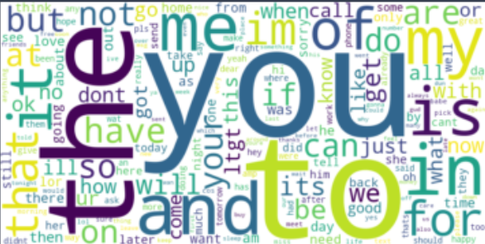
Fig 1.3 Wordcloud of Non Spam Messages CountVec Method

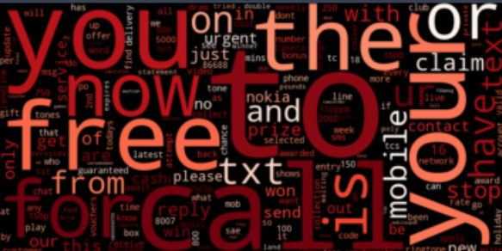
Fig 1.4 Wordcloud of Spam Messages CountVec Method

Figures 1.3 and 1.4 show the word clouds generated using the output from the vectorization process, as opposed to using the raw corpus to generate the word cloud. These visuals help show the contrast between the spam and non spam messages. We can observe some similarities noted above, such as the inclusion of “you” prominently in both wordclouds. We can also observe that the word “call” is in both word clouds, though featured much more prominently in the spam messages than it is in the non spam messages alluding the high frequency with which the word is used in the spam messages. And again, with the word “your”, we can observe that they occur in both word clouds, however the frequency with which “your” appears seems much higher than in the non spam messages.

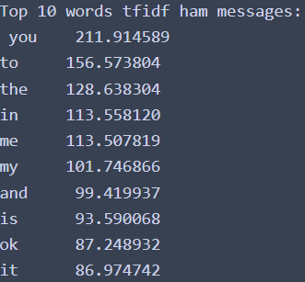
Fig 1.5 Top 10 Non-Spam Words for Tfidf Method
In figure 1.5 the top 10 words for non spam messages using the Tfidf Vectorizer can be observed. Many similarities between the top 10 words shown here and Fig 1.1 exist, with some repositioning of the words being the most prominent change. The one notable difference here is the inclusion of the word “ok” in this list when compared to the other list generated for the CountVec vectorizer.
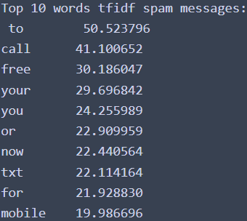
Fig 1.6 Top 10 Spam Words for Tfidf Method
In figure 1.6 the top 10 words for spam messages using the Tfidf vectorizer can be seen. Much like with Fig 1.5, the top 10 list here shares many similarities with the top 10 list in Fig 1.2. Just the same, there are some notable differences, such as the inclusion of the words “txt” and “mobile” in the list for this spam list compared to the other. And like with the non spam list, we see some reordering of the list when compared to the other spam messages list from Fig 1.2.

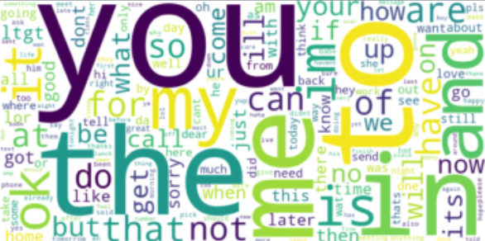
Fig 1.7 Word Cloud of Non-Spam Messages Using Tfidf

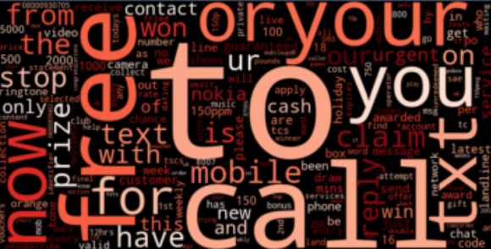
Fig 1.8 Word Cloud of Spam Messages Using Tfidf
In figures 1.7 and 1.8, the Word Clouds generated using the Tfidf vectorization output can be seen. Much like the top 10 list for the Tfidf method, many similarities can be observed between the word clouds generated using CountVec and the ones generated using Tfidf. Many of the same words appear in both word clouds, but based on the appearance of the word clouds, they place a different level of emphasis on words depending on method used.

Conclusion
The ability to process text data in a meaningful way has existed for some time, however, up until more recently, we have lacked the means to effectively process such data. The technique itself has been around for 75 years, but it wasn’t able to be deployed efficiently until storage capacity and compute capability were able to catch up. Now, large volumes of text data stored in a variety of formats can be used for text mining, including standards such as .txt, .csv, and corpus. The corpus format was explored here, where corpus was imported and vectorized to prepare for use with machine learning algorithms. The nuances between CountVec and Tfidf vectorization methods were investigated. While there are many similarities between the methods, differences do exist. As a result, before employing either vectorization technique, one should be familiar with these difference and how, if at all, it will affect the outcome of any machine learning algorithms used on the data. While many of the words have a similar level of importance placed on them, there is a variation between the methods. It is also worth noting that removing stop words was not performed beyond punctuation for this task, as the words being used in the messages carry meaning when compared to how sentences are structured in everyday speech. If this is not a consideration deemed necessary, removing these stop words will alter the output of the vectorization methods shown here.

References
[1] https://www.kaggle.com/datasets/coolkaggleuser/sms-spam-collection-data-set
Tiago A. Almeida Department of Computer Science (UFSCar) Sorocaba
*Paper from author(s) of dataset(corpus):
[1] Almeida, T.A., Gomez Hidalgo, J.M., Yamakami, A. Contributions to the study of SMS Spam Filtering: New Collection and Results. Proceedings of the 2011 ACM Symposium on Document Engineering (ACM DOCENG'11), Mountain View, CA, USA, 2011. (Under review)
** In accordance with License in readme:
We would appreciate if:
- In case you find this corpus useful, please make a reference to previous paper and the web page:
http://www.dt.fee.unicamp.br/~tiago/smsspamcollection/

